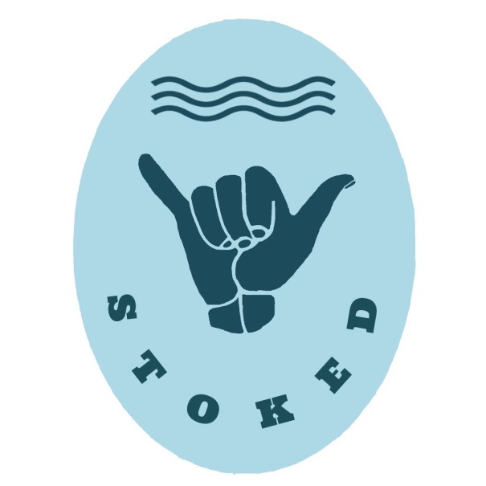
STOKED – Surf Therapy
Mentor Registration Form
Name:
Date of birth:
Contact number:
Dietary Requirements:
T-shirt size: | XS S M L XL XXL
Do you have a WWC? (please attach)
Do you hold a bronze?
(not essential)
What program are you interested in joining? | (Warrnambool, Portland, Port Fairy)

Which sessions can you attend?
Week | X | Week | X | Week | X | Week | X | Week | X | Week | X
1 |  | 2 |  | 3 |  | 4 |  | 5 |  | 6

STOKED may take photos and videos to be used for promotion, including media and social media. If you don’t want to be in any of these, please let us know in the box below.

Lived experience and shared story telling is a valuable part of our program. Whether it be related to mental health, substance use, hard times, wrong paths, close calls or epic fails. These personal storied can be super engaging and inspiring, perfect for getting good messages across to young people. Or do you have any skills or training to deliver an education session or facilitate a yarn circle?
I have some lived experience that I feel comfortable and passionate about sharing to a group:
Yes

I could facilitate an education session or yarn circle on the following topic/ topics:

Thanks again for your interest in joining the STOKED team, we are so grateful for everyone who puts their hand up to help. It’s so heart-warming to receive these forms back!
The sessions are usually help at the local Surf Life Saving Clubs. Mentors need to bring their own wetsuits but if you don’t have one, let me know, as we have some spares!
Could you please fill out the above registration form and email it back to me at cduncan@brophy.org.au Please also read the program overview on the Brophy website.
STOKED is still a new program and we are still finding our feet a bit, so let me know if we have missed anything or if you have any questions.

